SQL 查询示例

1.使用powershell进入 YMatrix 容器
docker exec -it e2e-ymatrix /opt/ymatrix/matrixdb5/bin/psql -h localhost -U mxadmin -d dw_demo
进入 psql 交互界面后，逐条执行以下 SQL：
-- 1. 查看所有表和分区
\dt
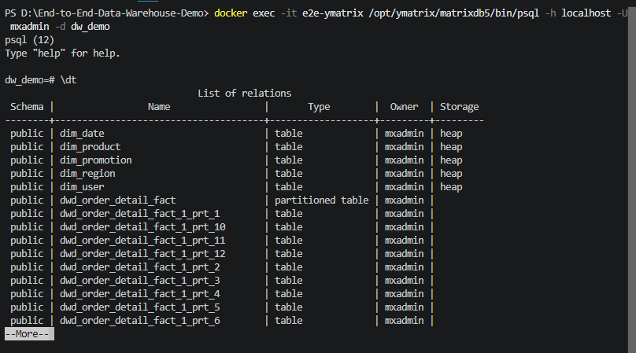

-- 2. 查看每日 GMV 趋势（前 10 天）SELECT dt, order_count, gmv, avg_order_amount FROM ads_daily_gmv ORDER BY dt LIMIT 10;
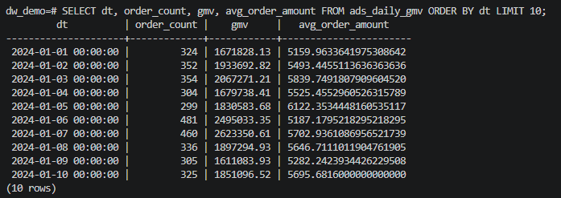

-- 3. 查看双11当天 GMV 对比日常SELECT dt, order_count, gmv FROM ads_daily_gmv WHERE dt IN ('2024-11-10','2024-11-11','2024-11-12') ORDER BY dt;
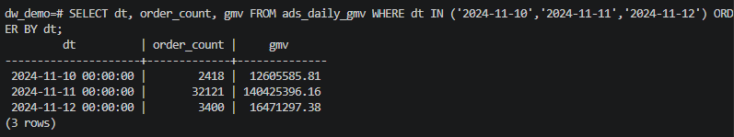

-- 4. 查看双11累计 GMV（逐分钟，前 10 分钟）SELECT bucket_time, minute_gmv, running_gmv, minute_order_count, running_order_count FROM ads_gmv_running_total ORDER BY bucket_time LIMIT 10;
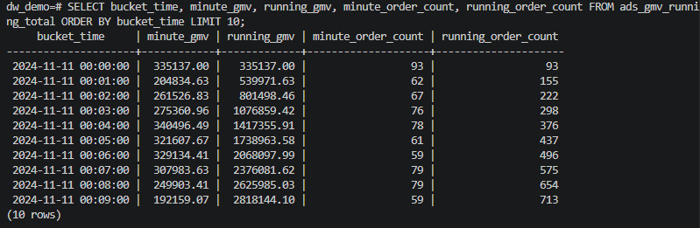

-- 5. 查看商品销售 Top 10SELECT product_name, category, total_qty, total_revenue FROM ads_top_products;

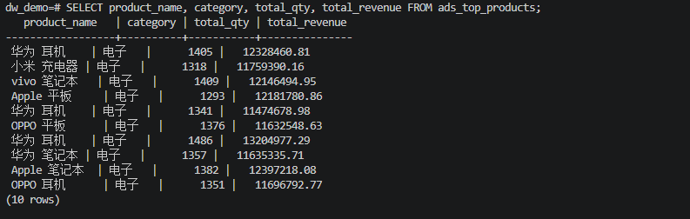

-- 6. 查看品类销售占比SELECT category, revenue, pct FROM ads_category_sales ORDER BY revenue DESC;
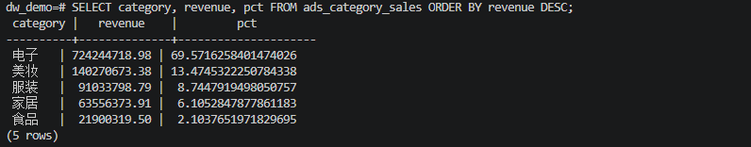

-- 7. 查看 GMV 按省份分布SELECT province, order_cnt, gmv FROM ads_gmv_by_region ORDER BY gmv DESC;
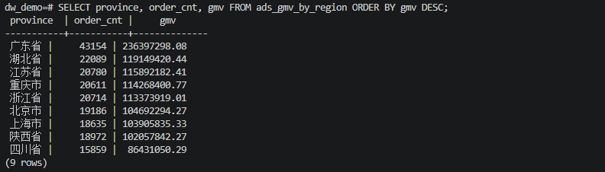

-- 8. 查看用户复购率SELECT repurchase_rate, repeat_buyers, total_buyers FROM ads_user_repurchase;
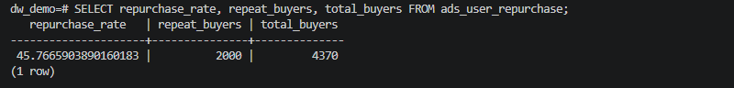

-- 9. 查看用户价值分层SELECT segment, user_count, total_orders FROM ads_user_segment ORDER BY segment;
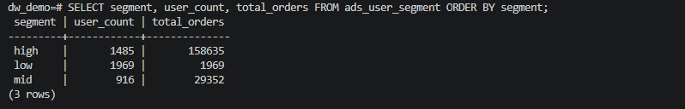

-- 10. 查看促销期 vs 日常期对比SELECT period, days, order_cnt, gmv, daily_avg_gmv, avg_order_value, uplift_pct FROM ads_promo_compare;
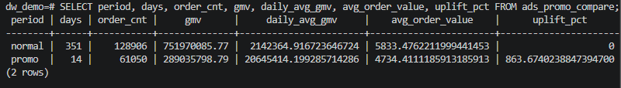

-- 11. 查看订单状态漏斗SELECT status, order_count FROM ads_order_status_funnel;
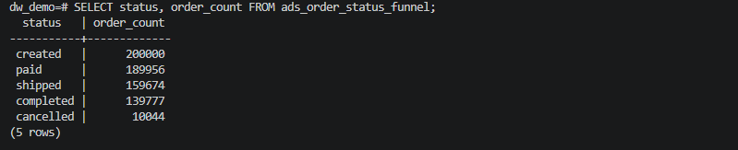

-- 12. 查看双11分钟级流量（前 20 分钟）SELECT bucket_time, minute_order_count, minute_gmv FROM ads_minute_traffic WHERE bucket_time >= TIMESTAMP '2024-11-11 00:00:00' AND bucket_time < TIMESTAMP '2024-11-12 00:00:00' ORDER BY bucket_time LIMIT 20;
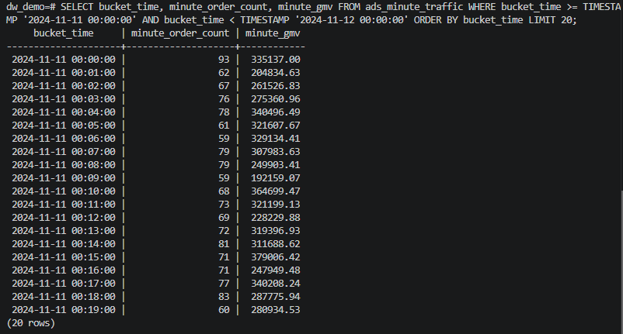

-- 13. 查看流量峰值 Top 20 分钟SELECT bucket_time, minute_order_count, minute_gmv FROM ads_traffic_peak_minutes;
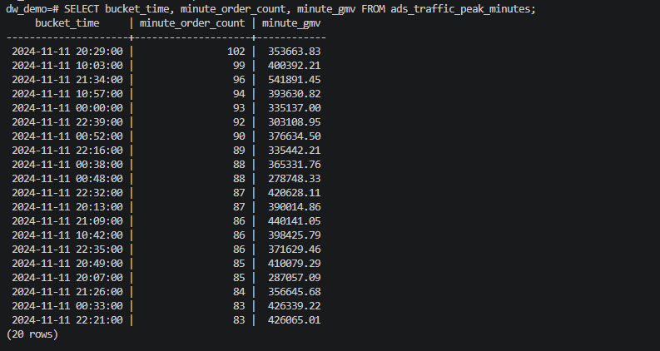

-- 14. 查看履约延迟（小时）SELECT paid_to_shipped_hours, shipped_to_completed_hours FROM ads_order_fulfillment_latency;
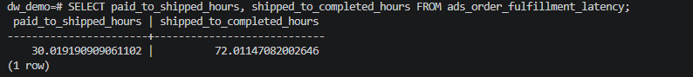

-- 15. 查看 MARS3 vs HEAP 压缩率对比SELECT pg_total_relation_size('ods_orders_mars_compare') AS mars3_bytes, pg_total_relation_size('ods_orders_heap') AS heap_bytes, ROUND((1.0 - 1.0 * pg_total_relation_size('ods_orders_mars_compare') / pg_total_relation_size('ods_orders_heap')) * 100, 1) AS savings_pct;
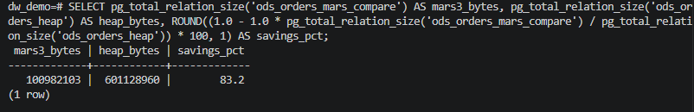

-- 16. 查看 ETL 审计日志SELECT log_id, step, status, rows_processed, duration_ms, log_time FROM etl_log ORDER BY log_id;
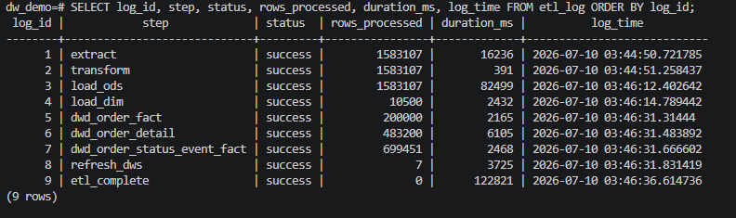
-- 退出 psql
\q

